ART THROUGH THE YEARS
- Renaissance Art
Renaissance art, painting, sculpture, architecture, music, and literature produced during the 14th, 15th, and 16th centuries in Europe under the combined influences of an increased awareness of nature, a revival of classical learning, and a more individualistic view of man. Scholars no longer believe that the Renaissance marked an abrupt break with medieval values, as is suggested by the French word renaissance, literally “rebirth.” Rather, historical sources suggest that interest in nature, humanistic learning, and individualism were already present in the late medieval period and became dominant in 15th- and 16th-century Italy concurrently with social and economic changes such as the secularization of daily life, the rise of a rational money-credit economy, and greatly increased social mobility.
Renaissance patrons wanted art that showed joy in human beauty and life’s pleasures. Renaissance art is more lifelike than in the art of the Middle Ages. Renaissance artists studied perspective, or the differences in the way things look when they are close to something or far away. The artists painted in a way that showed these differences. As a result, their paintings seem to have depth.
An artist from Florence named Giotto was one of the first to paint in this new style. Giotto lived more than a century before the beginning of the Renaissance, but his paintings show real emotion. The bodies look solid, and the background of his paintings shows perspective. The art produced during the Renaissance would build upon Giotto’s style.
Leonardo da Vinci was born in 1452 in the village of Vinci. His name means Leonardo of Vinci. Leonardo began his career working for a master painter in Florence. By 1478, Leonardo left his master and set up his own workshop. People have been trying to guess the secret behind the smile of his Mona Lisa ever since he painted it around 1505. His Last Supper shows clearly the different feelings of Jesus and his followers.
Leonardo’s fame grew—but not just for his painting. Leonardo was truly a “Renaissance Man,” skilled in many fields. He was a scientist and an inventor as well as an artist. He made notes and drawings of everything he saw. Leonardo invented clever machines, and even designed imitation wings that he hoped would let a person fly like a bird.
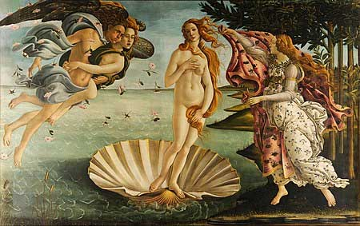
The Birth of Venus by Italian artist Sandro Botticelli (c. 1480s). The painting depicts the goddess Venus arriving at the shore after her birth, when she had emerged from the sea fully-grown.
Michelangelo Buonarroti of Florence was one of the greatest artists of all time. Like Leonardo, Michelangelo was a “Renaissance Man” of many talents. He was a sculptor, a painter, and an architect. When Michelangelo carved a statue of Moses, he included veins and muscles in the arms and legs.
Michelangelo was a devout Christian, and the church was his greatest patron. He designed the dome of St. Peter’s church in Rome. Nearby, Michelangelo’s paintings cover the ceiling of the Sistine Chapel, the building where new popes have been selected for more than five hundred years. Michelangelo’s painting illustrates the Book of Genesis, with scenes that span from the Creation to the Flood. The project was very difficult. Working alone, Michelangelo had to lie on his back atop high scaffolding while he painted the vast ceiling.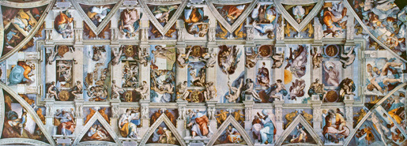
The ceiling of the Sistine Chapel is one of the world’s most famous paintings, but not everyone was happy with Michelangelo’s work. Cardinal Biagio de Cesena noted that the crowd of more than 300 human figures would be more appropriate in a wine shop than in a papal chapel. Michelangelo responded to this criticism by adding a portrait of Biagio (below) among the figures of the damned in the scene of the Last Judgment.

- Baroque Art
The Baroque (US: /bəˈroʊk/ or UK: /bəˈrɒk/) is a highly ornate and often extravagant style of architecture, art and music that flourished in Europe from the early 17th until the mid-18th century. It followed the Renaissance styleand preceded the Rococo (in the past often referred to as "late Baroque") and Neoclassical styles. It was encouraged by the Catholic Church as a means to counter the simplicity and austerity of Protestant architecture, art and music, though Lutheran Baroque art developed in parts of Europe as well The Baroque style used contrast, movement, exuberant detail, deep colour, grandeur and surprise to achieve a sense of awe. The style began at the start of the 17th century in Rome, then spread rapidly to France, northern Italy, Spain and Portugal, then to Austria and southern Germany. By the 1730s, it had evolved into an even more flamboyant style, called rocaille or Rococo, which appeared in France and central Europe until the mid to late 18th century.

The Baroque
Baldachino of St. Peter's Basilica by Bernini; Louis XIV by Bernini;Adoration of the Magi by Peter Paul Rubens; Wieskirche, Bavaria
Years active | 17th–18th century

- Neoclassicism
Neoclassicism (from Greek νέος nèos, "new" and Latin classicus, "of the highest rank")^{[1]} is the name given to Western movements in the decorative and visual arts, literature, theatre, music, and architecture that draw inspiration from the "classical" art and culture of classical antiquity. Neoclassicism was born thanks to the writings of Johann Joachim Winckelmann, at the time of the rediscovery of Pompeii and Herculaneum, but its popularity spread all over Europe as a generation of European art students finished their Grand Tour and returned from Italy to their home countries with newly rediscovered Greco-Roman ideals.^{[2][3]} The main Neoclassical movement coincided with the 18th-century Age of Enlightenment, and continued into the early 19th century, laterally competing with Romanticism. In architecture, the style continued throughout the 19th, 20th and up to the 21st century.
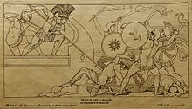
Print of a drawing by John Flaxmanof a scene in Homer's Iliad, 1795
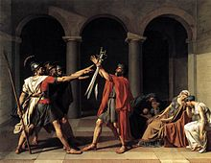
Jacques-Louis David, Oath of the Horatii, 1784
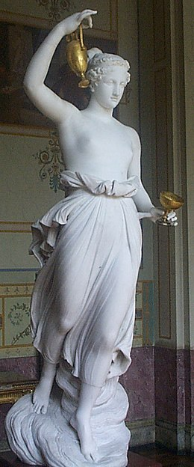
Hebe by Canova (1800–05), in the appropriately Neoclassical surroundings of the Hermitage Museum
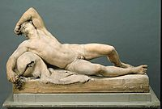
If Neoclassical painting suffered from a lack of ancient models, Neoclassical sculpture tended to suffer from an excess of them, although examples of actual Greek sculpture of the "classical period" beginning in about 500 BC were then very few; the most highly regarded works were mostly Roman copies. Most of the great figures of the Enlightenment, and travelled to America to produce a statue of George Washington, as well as busts of Thomas Jefferson, Ben Franklin and other luminaries of the new republic.
Resting Faun, 1770, Johan Tobias Sergel

- Romanticism
Romanticism (also known as the Romantic era) was an artistic, literary, musical and intellectual movement that originated in Europe toward the end of the 18th century, and in most areas was at its peak in the approximate period from 1800 to 1850. Romanticism was characterized by its emphasis on emotion and individualism as well as glorification of all the past and nature, preferring the medieval rather than the classical. It was partly a reaction to the Industrial Revolution, the aristocratic social and political norms of the Age of Enlightenment, and the scientific rationalization of nature—all components of modernity. It was embodied most strongly in the visual arts, music, and literature, but had a major impact on historiography, education, the social sciences, and the natural sciences. It had a significant and complex effect on politics, with romantic thinkers influencing liberalism, radicalism, conservatism and nationalism.
The movement emphasized intense emotion as an authentic source of aesthetic experience, placing new emphasis on such emotions as apprehension, horror and terror, and awe—especially that experienced in confronting the new aesthetic categories of the sublimity and beauty of nature. It elevated folk art and ancient custom to something noble, but also spontaneity as a desirable characteristic (as in the musical impromptu). In contrast to the Rationalism and Classicism of the Enlightenment, Romanticism revived medievalism and elements of art and narrative perceived as authentically medieval in an attempt to escape population growth, early urban sprawl, and industrialism.
In summation Romanticism stressed:
- a deepened appreciation of the beauties of nature;
- a general exaltation of emotion over reason and of the senses over intellect;
- a turning in upon the self and a heightened examination of human personality and its moods and mental potentialities;
- a preoccupation with the genius, the hero, and the exceptional figure in general, and a focus on his passions and inner struggles;
- a new view of the artist as a supremely individual creator, whose creative spirit is more important than strict adherence to formal rules and traditional procedures;
- an emphasis upon imagination as a gateway to transcendent experience and spiritual truth;
- an obsessive interest in folk culture, national and ethnic cultural origins, and the medieval era;
- and finally a predilection for the exotic, the remote, the mysterious, the weird, the occult, the monstrous, the diseased, and even the satanic
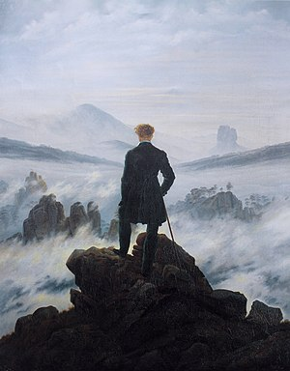
Caspar David Friedrich, Wanderer Above the Sea of Fog, 1818

- Impressionism
Impressionism is a 19th-century art movement characterized by relatively small, thin, yet visible brush strokes, open composition, emphasis on accurate depiction of light in its changing qualities (often accentuating the effects of the passage of time), ordinary subject matter, inclusion of movement as a crucial element of human perception and experience, and unusual visual angles. Impressionism originated with a group of Paris-based artists whose independent exhibitions brought them to prominence during the 1870s and 1880s.
The Impressionists faced harsh opposition from the conventional art community in France. The name of the style derives from the title of a Claude Monet work, Impression, soleil levant (Impression, Sunrise), which provoked the critic Louis Leroy to coin the term in a satirical review published in the Parisian newspaper Le Charivari.
The development of Impressionism in the visual arts was soon followed by analogous styles in other media that became known as impressionist music and impressionist literature.
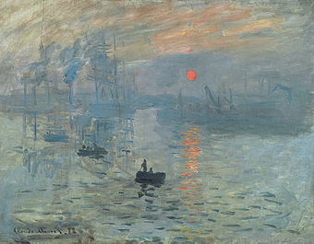
Claude Monet, Impression, soleil levant (Impression, Sunrise), 1872, oil on canvas, Musée Marmottan Monet, Paris. This painting became the source of the movement's name, after Louis Leroy's article The Exhibition of the Impressionists satirically implied that the painting was at most, a sketch.

- Pointillism

Pointillism (/ˈpɔɪntɪlɪzəm/) is a technique of painting in which small, distinct dots of color are applied in patterns to form an image.
Georges Seurat and Paul Signac developed the technique in 1886, branching from Impressionism. The term "Pointillism" was coined by art critics in the late 1880s to ridicule the works of these artists, and is now used without its earlier mocking connotation. The movement Seurat began with this technique is known as Neo-impressionism. The Divisionists, too, used a similar technique of patterns to form images, though with larger cube-like brushstrokes.

- Expressionism
Expressionism, artistic style in which the artist seeks to depict not objective reality but rather the subjective emotions and responses that objects and events arouse within a person. The artist accomplishes this aim through distortion, exaggeration, primitivism, and fantasy and through the vivid, jarring, violent, or dynamic application of formal elements. In a broader sense Expressionism is one of the main currents of art in the later 19th and the 20th centuries, and its qualities of highly subjective, personal, spontaneous self-expression are typical of a wide range of modern artists and art movements. Expressionism can also be seen as a permanent tendency in Germanic and Nordic art from at least the European Middle Ages, particularly in times of social change or spiritual crisis, and in this sense it forms the converse of the rationalist and classicizing tendencies of Italy and later of France.
More specifically, Expressionism as a distinct style or movement refers to a number of German artists, as well as Austrian, French, and Russian ones, who became active in the years before World War I and remained so throughout much of the interwar period.
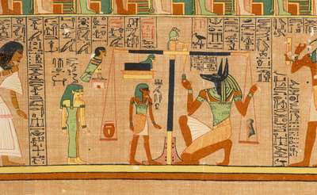

- Cubism
"Cubism is like standing at a certain point on a mountain and looking around. If you go higher, things will look different; if you go lower, again they will look different. It is a point of view."
The artists abandoned perspective, which had been used to depict space since the Renaissance, and they also turned away from the realistic modeling of figures.
Cubists explored open form, piercing figures and objects by letting the space flow through them, blending background into foreground, and showing objects from various angles. Some historians have argued that these innovations represent a response to the changing experience of space, movement, and time in the modern world. This first phase of the movement was called Analytic Cubism.
In the second phase of Cubism, Synthetic Cubists explored the use of non-art materials as abstract signs. Their use of newspaper would lead later historians to argue that, instead of being concerned above all with form, the artists were also acutely aware of current events, particularly WWI.
Cubism paved the way for non-representational art by putting new emphasis on the unity between a depicted scene and the surface of the canvas. These experiments would be taken up by the likes of Piet Mondrian, who continued to explore their use of the grid, abstract system of signs, and shallow space.
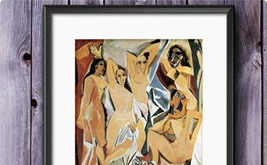
A watershed moment for the development of Cubism was the posthumous retrospective of Paul Cézanne's work at the Salon d'Automne in 1907. Cézanne's use of generic forms to simplify nature was incredibly influential to both Picasso and Braque. In the previous year, Picasso was also introduced to non-Western art: seeing Iberian art in Spain, and African-influenced art by Matisse, and at the Trocadero anthropological museum. What drew Picasso to these artistic traditions was their use of an abstract or simplified representation of the human body rather than the naturalistic forms of the European Renaissance tradition.
- Fauvism
Fauvism is the style of les Fauves (French for "the wild beasts"), a group of early twentieth-century modern artists whose works emphasized painterly qualities and strong color over the representational or realistic values retained by Impressionism. While Fauvism as a style began around 1904 and continued beyond 1910, the movement as such lasted only a few years, 1905–1908, and had three exhibitions.The leaders of the movement were André Derain and Henri Matisse.
Fauvism, style of painting that flourished in France around the turn of the 20th century. Fauve artists used pure, brilliant colour aggressively applied straight from the paint tubes to create a sense of an explosion on the canvas.
The Fauves painted directly from nature, as the Impressionists had before them, but Fauvist works were invested with a strong expressive reaction to the subjects portrayed. First formally exhibited in Paris in 1905, Fauvist paintings shocked visitors to the annual Salon d’Automne; one of these visitors was the critic Louis Vauxcelles, who, because of the violence of their works, dubbed the painters fauves (“wild beasts”).
The leader of the group was Henri Matisse, who had arrived at the Fauve style after experimenting with the various Post-Impressionist approaches of Paul Gauguin, Vincent van Gogh, and Georges Seurat. Matisse’s studies led him to reject traditional renderings of three-dimensional space and to seek instead a new picture space defined by movement of colour. He exhibited his famous Woman with the Hat (1905) at the 1905 exhibition. In this painting, brisk strokes of colour—blues, greens, and reds—form an energetic, expressive view of the woman. The crude paint application, which left areas of raw canvas exposed, was appalling to viewers at the time.
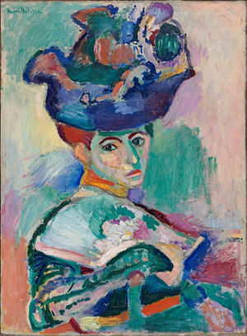

Henri Matisse. Woman with a Hat, 1905. San Francisco Museum of Modern Art

- Dada
Dada, nihilistic and antiaesthetic movement in the arts that flourished primarily in Zürich, Switzerland; New York City; Berlin, Cologne, and Hannover, Germany; and Paris in the early 20th century.
Several explanations have been given by various members of the movement as to how it received its name. According to the most widely accepted account, the name was adopted at Hugo Ball’s Cabaret Voltaire in Zürich, during one of the meetings held in 1916 by a group of young artists and war resisters that included Jean Arp, Richard Hülsenbeck, Tristan Tzara, Marcel Janco, and Emmy Hennings. When a paper knife inserted into a French-German dictionary pointed to the French word dada (“hobby-horse”), it was seized upon by the group as appropriate for their anti-aesthetic creations and protest activities, which were engendered by disgust for bourgeois values and despair over World War I. Dada did not constitute an actual artistic style, but its proponents favoured group collaboration, spontaneity, and chance. In the desire to reject traditional modes of artistic creation, many Dadaists worked in collage, photomontage, and found-object construction, rather than in painting and sculpture.
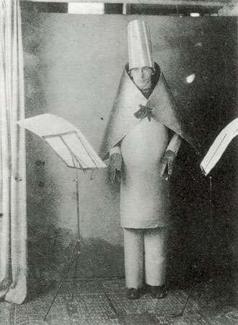
Ball, HugoHugo Ball, 1916.Unknown
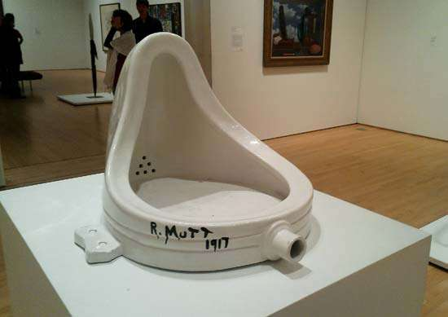

Surrealism
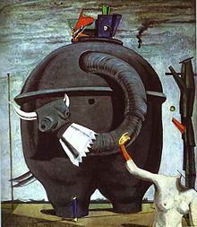
Max Ernst, The Elephant Celebes, 1921, TateLondon
Years active | 1920s–1930s
Country | France, Belgium
Major figures | Breton, Dalí, Ernst, Magritte
Influences | Dada
Influenced | Abstract expressionism, Post-modernism

Duchamp, Marcel: FountainFountain, ready-made by Marcel Duchamp, replica of the 1917 original (now lost).art@aditi

- Surrealism
Surrealism, movement in visual art and literature, flourishing in Europe between World Wars I and II. Surrealism grew principally out of the earlier Dada movement, which before World War Iproduced works of anti-art that deliberately defied reason; but Surrealism’s emphasis was not on negation but on positive expression. The movement represented a reaction against what its members saw as the destruction wrought by the “rationalism” that had guided European culture and politics in the past and that had culminated in the horrors of World War I. According to the major spokesman of the movement, the poet and critic André Breton, who published The Surrealist Manifesto in 1924, Surrealism was a means of reuniting conscious and unconsciousrealms of experience so completely that the world of dream and fantasy would be joined to the everyday rational world in “an absolute reality, a surreality.” Drawing heavily on theories adapted from Sigmund Freud, Breton saw the unconscious as the wellspring of the imagination. He defined genius in terms of accessibility to this normally untapped realm, which, he believed, could be attained by poets and painters alike.

Surrealist works feature the element of surprise, unexpected juxtapositions and non sequitur; however, many surrealist artists and writers regard their work as an expression of the philosophical movement first and foremost, with the works being an artifact. Leader André Breton was explicit in his assertion that Surrealism
was, above all, a revolutionary movement.

Surrealism developed out of the Dada activities during World War I and the most important center of the movement was Paris. From the 1920s onward, the movement spread around the globe, eventually affecting the visual arts, literature, film, and music of many countries and languages, as well as political thought and practice, philosophy, and social theory.

- Abstract Expressionism
"It is a widely accepted notion among painters that it does not matter what one paints as long as it is well painted. This is the essence of academic painting. However, there is no such thing as good painting about nothing."
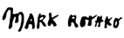
"Abstract Expressionism" was never an ideal label for the movement, which developed in New York in the 1940s and 1950s. It was somehow meant to encompass not only the work of painters who filled their canvases with fields of color and abstract forms, but also those who attacked their canvases with a vigorous gestural expressionism. Still Abstract Expressionism has become the most accepted term for a group of artists who held much in common. All were committed to art as expressions of the self, born out of profound emotion and universal themes, and most were shaped by the legacy of Surrealism, a movement that they translated into a new style fitted to the post-war mood of anxiety and trauma. In their success, these New York painters robbed Paris of its mantle as leader of modern art, and set the stage for America's dominance of the international art world.
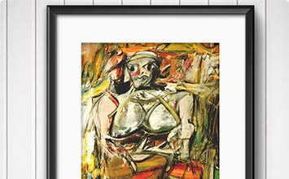

It is one of the many paradoxes of Abstract Expressionism that the roots of the movement lay in the figurative painting of the 1930s. Almost all the artists who would later become abstract painters in New York in the 1940s and 1950s were stamped by the experience of the Great Depression, and they came to maturity whilst painting in styles influenced by Social Realism and the Regionalist movements.
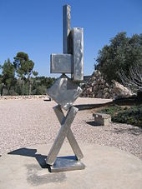
David Smith, Cubi VI(1963), Israel Museum, Jerusalem. David Smith was one of the most influential American sculptors of the 20th century.
By the late 1940s most had left those styles behind, but they learned much from their early work. It encouraged them in their commitment to an art based on personal experience. Time spent painting murals would later encourage them to create abstract paintings on a similarly monumental scale. The experience of working for the government-sponsored Works Progress Administration also brought many disparate figures together, and this would make it easier for them to band together again in the late 1940s and early 1950s when the new style was being promoted.
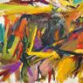  - Pop Art | Bullfight (1959)  Artist: Elaine de Kooning  Artwork description & Analysis: Bullfight is a boisterous expression of passion and color in varied brushstrokes, which cover the canvas in a sort of chaotic symmetry. The artist has said of her style: "I'm more interested in character than style. Character comes out of the work. Style is applied or imposed on the work. Style can be a prison." Her work is known for this impulse toward freedom along with movement, attention to balance and design and deliberate choices about color, form and composition.
Pop art is an art movement that emerged in Britain and the United States during the mid- to late-1950s. The movement presented a challenge to traditions of fine art by including imagery from popular and mass culture, such as advertising, comic books and mundane cultural objects. One of its aims is to use images of popular (as opposed to elitist) culture in art, emphasizing the banal or kitschy elements of any culture, most often through the use of irony. It is also associated with the artists' use of mechanical means of reproduction or rendering techniques. In pop art, material is sometimes visually removed from its known context, isolated, or combined with unrelated material.
Among the early artists that shaped the pop art movement were Eduardo Paolozzi and Richard Hamilton in Britain, and Larry Rivers, Robert Rauschenberg and Jasper Johns among others in the United States. Pop art is widely interpreted as a reaction to the then-dominant ideas of abstract expressionism, as well as an expansion of those ideas Due to its utilization of found objects and images, it is similar to Dada. Pop art and minimalism are considered to be art movements that precede postmodern art, or are some of the earliest examples of postmodern art themselves
Pop art often takes imagery that is currently in use in advertising. Product labeling and logos figure prominently in the imagery chosen by pop artists, seen in the labels of Campbell's Soup Cans, by Andy Warhol. Even the labeling on the outside of a shipping box containing food items for retail has been used as subject matter in pop art, as demonstrated by Warhol's Campbell's Tomato Juice Box, 1964
Andy Warhol, Campbell's Tomato Juice Box, 1964. Synthetic polymer paint and silkscreen ink on wood, 10 inches × 19 inches × 9½ inches (25.4 × 48.3 × 24.1 cm), Museum of Modern Art, New York City
- Op Art

Op art, also called optical art, branch of mid-20th-century geometric abstract art that deals with optical illusion. Achieved through the systematic and precise manipulation of shapes and colours, the effects of Op art can be based either on perspective illusion or on chromatic tension; in painting, the dominant medium of Op art, the surface tension is usually maximized to the point at which an actual pulsation or flickering is perceived by the human eye. In its concern with utterly abstract formal relationships, Op art is indirectly related to such other 20th-century styles as Orphism, Constructivism, Suprematism, and Futurism—particularly the latter because of its emphasis on pictorial movement and dynamism. The painters of this movement differed from earlier artists working in geometric styles, however, in their purposeful manipulation of formal relationships in order to evoke perceptual illusions, ambiguities, and contradictions in the vision of the viewer.
The principal artists of the Op art movement as it emerged in the late 1950s and ’60s were Victor Vasarely, Bridget Riley, Richard Anuszkiewicz, Larry Poons, and Jeffrey Steele. The movement first attracted international attention with the Op exhibition “The Responsive Eye” at the Museum of Modern Art in New York City in 1965. Op art painters devised complex and paradoxical optical spaces through the illusory manipulation of such simple repetitive forms as parallel lines, checkerboard patterns, and concentric circles or by creating chromatic tensionfrom the juxtaposition of complementary (chromatically opposite) colours of equal intensity. These spaces create the illusion of movement, preventing the viewer’s eye from resting long enough on any one part of the surface to be able to interpret it literally. “Op art works exist,” according to one writer, “less as objects than as generators of perceptual responses.”
Riley, Bridget: FallFall, polyvinyl acetate paint on hardboard by Bridget Riley, 1963; in Tate Modern, London.Courtesy of the trustees of The Tate, London
Op art goals were shared by the French Groupe de Recherche d’Art Visuel (“Group for Research in the Visual Arts”) and by the Venezuelan-born artist Jesús Rafael Soto. These artists made large-scale sculptures that employed light and motors, as well as sculptural materials, to create the illusion of movement in space that is fundamental to all Op art.

